Java Assignment 1 Documentation

Interface 1: Server

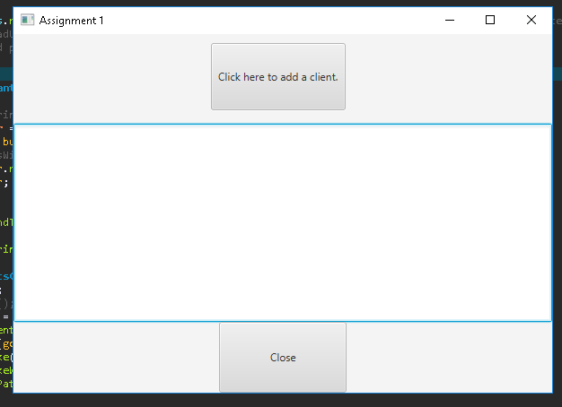

Server will display whatever data is piped through it in the main TextArea in the middle. Close button closes application (server + clients), Add Client button initialises a client and adds it to list of connected clients.

Upon clicking, login prompt displayed first before fully initialising client; this feeds username data into the client and thus also the server.

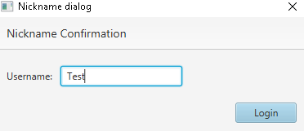

Interface 2: Client

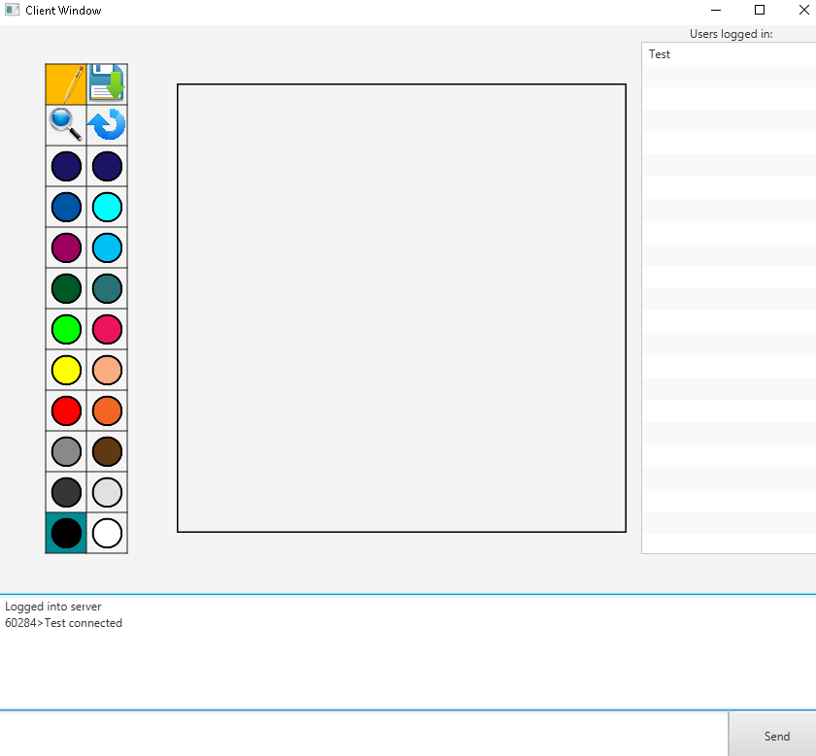

Tool panel on the left, canvas in middle, user list on right, server log bottom upper, chat field bottom lower.

Pencil tool selected by default; functionality built so you can select other tools (and selected tool background changes to orange). Currently only pencil and zoom work as such as tools; however zoom function is not yet fully implemented. Save and rotate functions are not tools, but are implemented. Save will save file to disk using a file chooser:

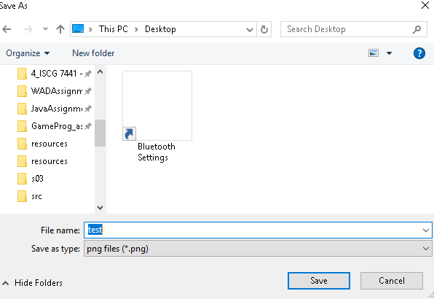 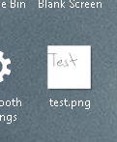and rotate tool will rotate canvas 90degrees CW.

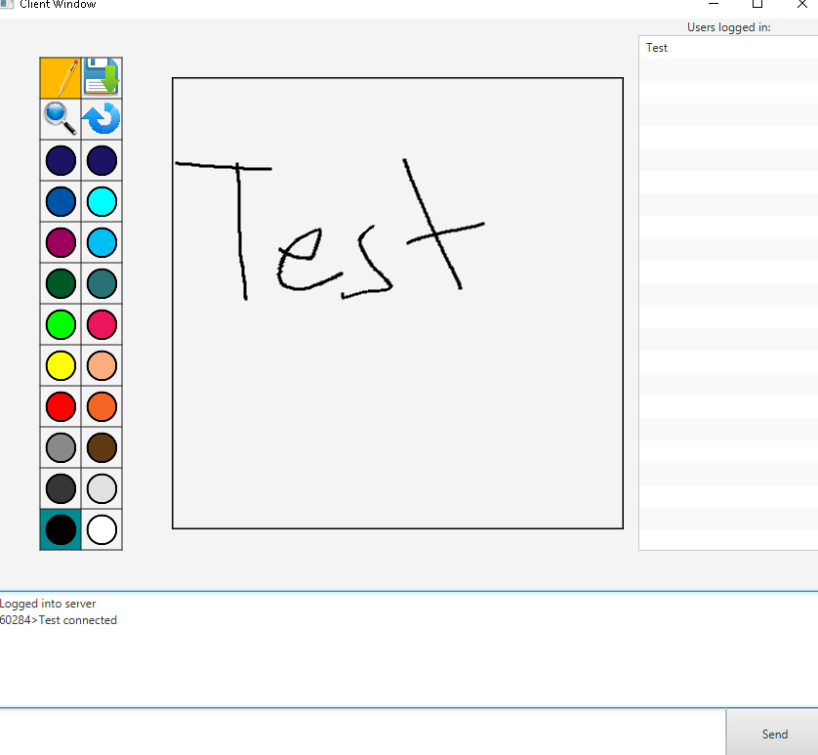 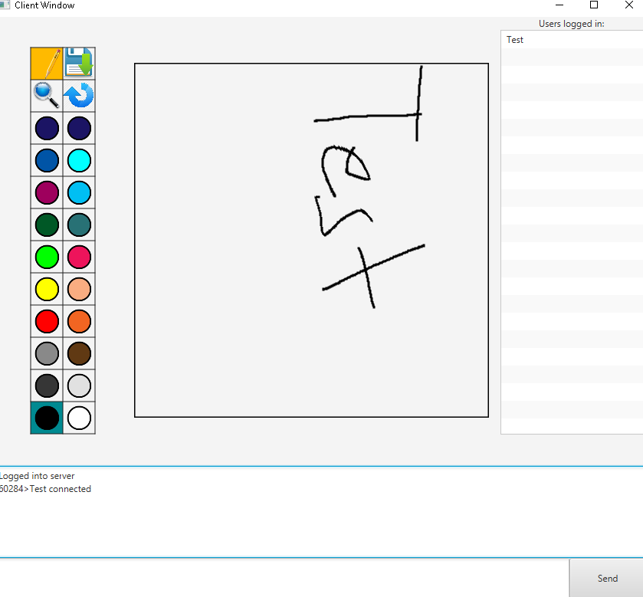

Selecting another colour will change the selected colour background to the selected colour and will change stroke colour to selected colour.

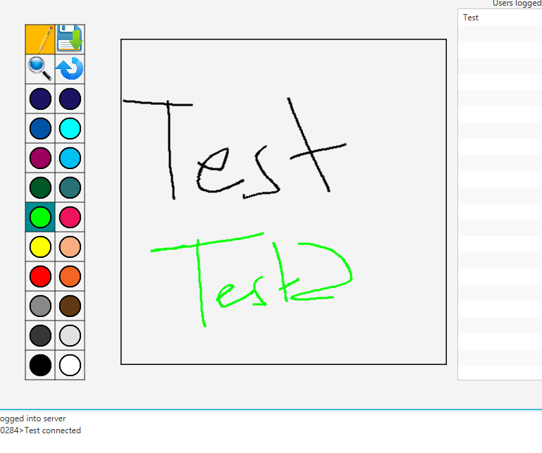

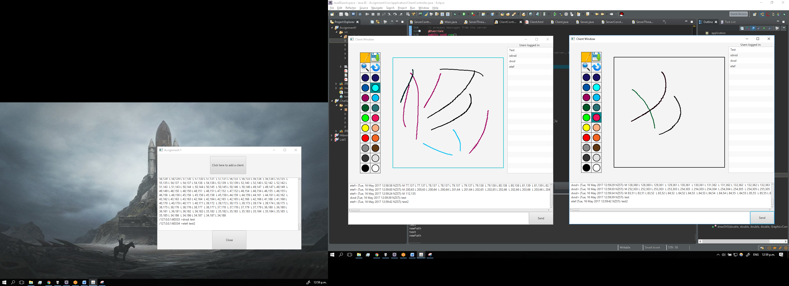

Currently able to send text data but not image data. Image data is being sent over network to other clients as string, but graphics context of receiving clients is not yet able to render from stream.